Say Hello to Microsoft Edge!

Microsoft comes all guns blazing with Microsoft edge to take on existing Browsers

The project, codenamed ‘Project Spartan’, derived from Microsoft’s veteran game Halo, is about to reach its completion as Microsoft has unveiled its new Web Browser which will eventually replace the dull Internet Explorer. Microsoft Edge, would be lighter and faster than the existing Internet Explorer and will also come packed with lots of new features! Edge will be the default web browser in Windows 10 operating system.

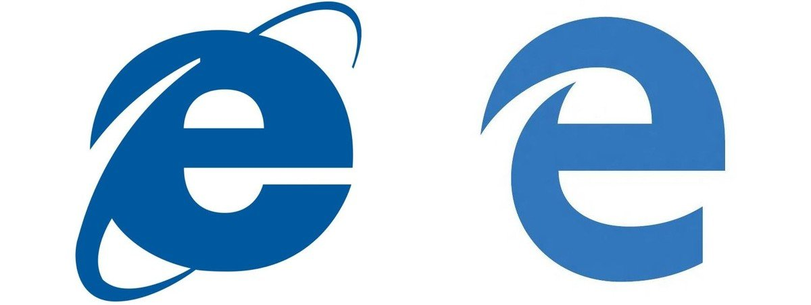

Not much difference in the logo, but way better than the Internet Explorer

Will it remain useful for office works as Internet Explorer was?

As per the officials, Microsoft has claimed that the Microsoft Edge will inherit all the existing office tools from Internet Explorer, but will get a makeover in order to provide a better experience to the users. Along with that, all the security and safety programmes from the Explorer have been preserved, plus it will be loaded with new mechanisms to ensure privacy and safety to its users! With all these, Microsoft has made sure that their loyal users don’t find any difficulty in using the all new software.

What’s New?

Along with all the existing features, Microsoft has made their software appealing with tons of new features. These new features include a built-in notation tool, a distraction-free reading mode, website information tool, and Cortana, a personal voice-assistant app for windows. The name Edge refers to the idea of being the edge of consuming and creating, said Mr Belfiore, Microsoft official. Along with the above features, simple things have also been taken care of, like note-taking and innovative interface of reading and consuming content. The Cortana built-in is loaded with all its Artificial intelligence programs, so it learns the things that one cares about and help one get things done.

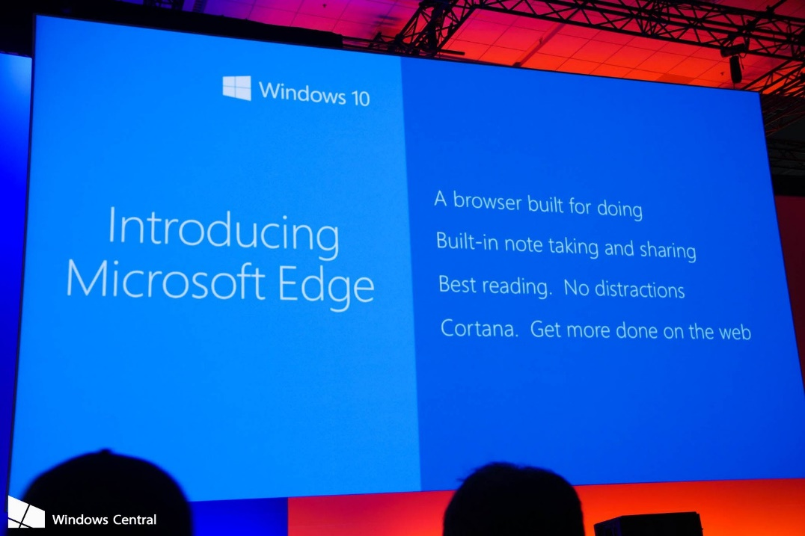

Edge, a Windows Developer’s Paradise!

Microsoft, has taken care of the developers along with those of loyal veteran users and masses. Microsoft Edge will enable developers to engage with different sites and gives them a shot at starting to write some Web Code, which can later be put into an app via Web Extensions built into the software. The company is going to enable people to discover and engage with codes shared by developers on the Web.

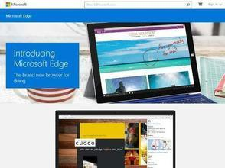

With all these additions to widely used Internet Explorer, Microsoft has taken a huge step in redefining the meaning of a Web Browser. Microsoft Edge will be available only for Windows 10 and further. Thank you Microsoft for taking care of everyone!